HOW TO FIND LTDER



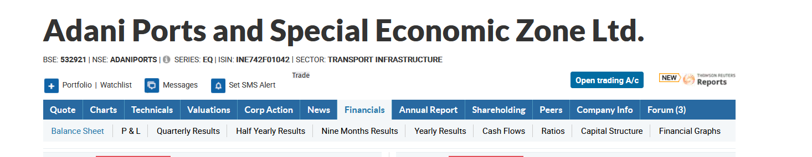

Go to balance sheet tab for each company

Under consolidated, long term borrowings and total shareholders fund present: 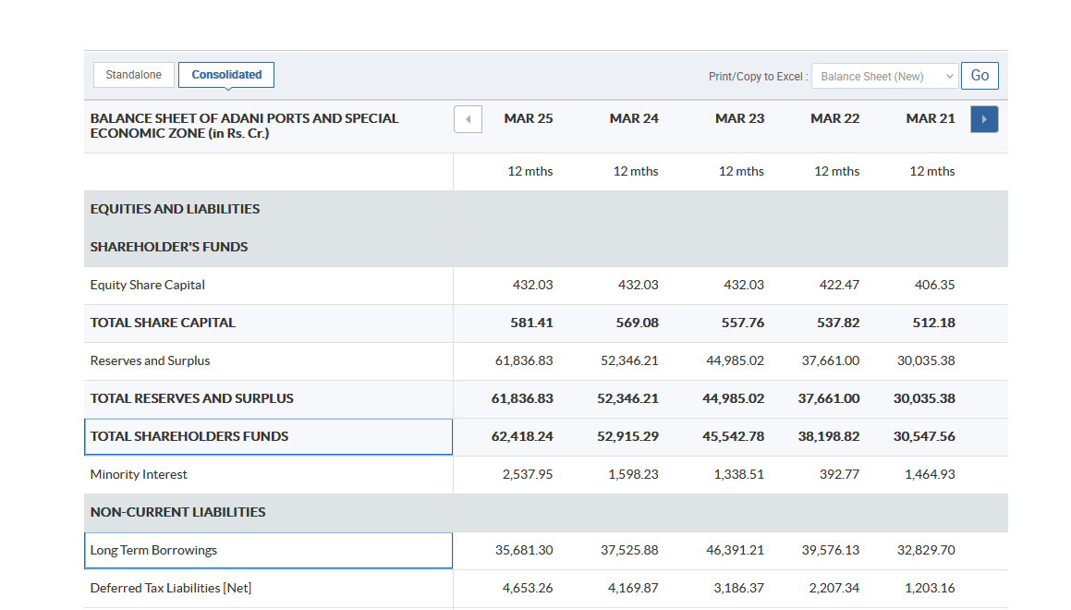

**📘 Formula**

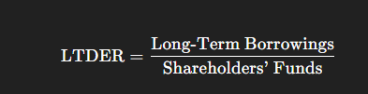

**📊 From your pasted data**

| **Item (Moneycontrol heading)** | **What it means** | **Use for LTDER** |
| --- | --- | --- |
| **Long Term Borrowings** | The company’s *long-term secured and unsecured debt*. | ✅ **Numerator** |
| **Total Shareholders Funds** | Equity Share Capital + Reserves & Surplus (Net worth). | ✅ **Denominator** |

**✅ Example calculation (FY 2025)**

LTDER2025=47,783.6630,419.44=1.57\text{LTDER}_{2025} = \frac{47,783.66}{30,419.44} = 1.57LTDER2025​=30,419.4447,783.66​=1.57

So LTDER ≈ **1.57 ×** for FY 2025.

You can repeat this for every year:

| **Year** | **Long Term Borrowings** | **Shareholders Funds** | **LTDER = Debt ÷ Equity** |
| --- | --- | --- | --- |
| 2025 | 47,783.66 | 30,419.44 | 1.57 |
| 2024 | 43,539.85 | 29,324.68 | 1.14 |
| 2023 | 43,935.97 | 28,661.89 | 1.18 |
| 2022 | 40,511.30 | 26,531.08 | 1.15 |
| 2021 | 30,844.29 | 21,740.58 | 1.42 |

HOW TO FIND ART

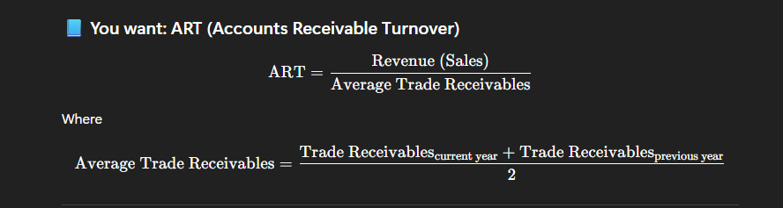

Trade recievables present under balance sheet like previous one:

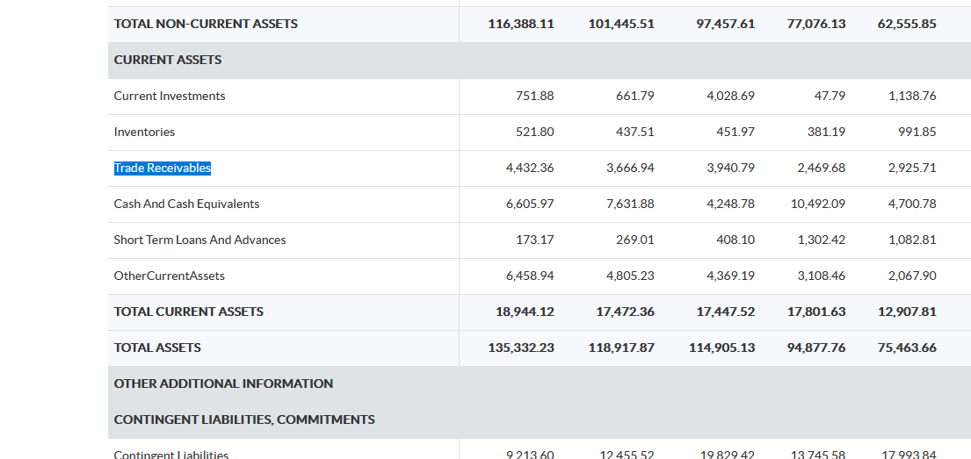

You still need **Revenue from Operations (Net Sales)** for each year — that’s **not shown in the Balance Sheet**.

You can get it easily from:  
**Moneycontrol → Financials → Profit & Loss (P&L)** tab → “Revenue from Operations (₹ Cr)”.



**Under consolidated**

